TILT & TAP Gestures Footswitch: Quick Start Guide

But first…A Few notes:

* The tilt sensor uses magnetic orientation to calculate it’s relative angle to the Earth. …which means the tilt sensor is sensitive to ANYthing that changes magnetic fields.
* At startup, or Arduino serial connection the processor calculates the starting sensor angle and uses that to remove initial conditions offsets. I recommend re-initializing after changing the sensors location or starting orientation. For example, if I setup the tool on my work bench, then move across my lab next to my water heater…the sensor’s relative output totally changes!...I need to re-init after changing my working location in my lab.
* Tilt and Tap uses two adjustable variables to set the tilt and tap thresholds.
* Both variables are stored in config.h at the top of the file:
  + ////////////////////////////////
  + // USER PARAMETERS//
  + ////////////////////////////////
  + **int** guestureThreshold = -25;
  + **int** TapThreshold = 80;
* Total acceleration is now scaled down to read from between zero and 100.
* Tilt angle (in arbitrary units) is not absolute, but relative to vertical. Meaning, depending on how you hold the footswitch, if you tilt forward you may get a positive number, but if you rotate the footswitch and tilt forward you may get a negative number.

# QUICK START

1. Plug the USB programmer module into the computer
2. Start Arduino IDE and select COM Port for programmer. Note if programming, select Board to “RFduino”

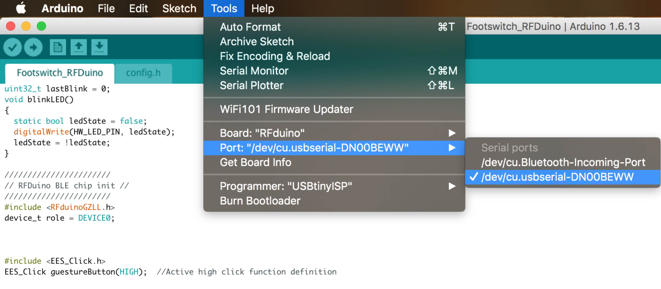

1. Start Plotting!

There are 5 channels of data, built around using the Arduino Serial Plotter which overlays all channels on one screen. So all data is scaled to be under 100, so it can be viewed on the same scale to other variables.

Data structure is defined:

[Tilt Data, Setpoint1, Accel Data, Setpoint2, Mode]

Example: “0,-25,6,80,0”

* 1. 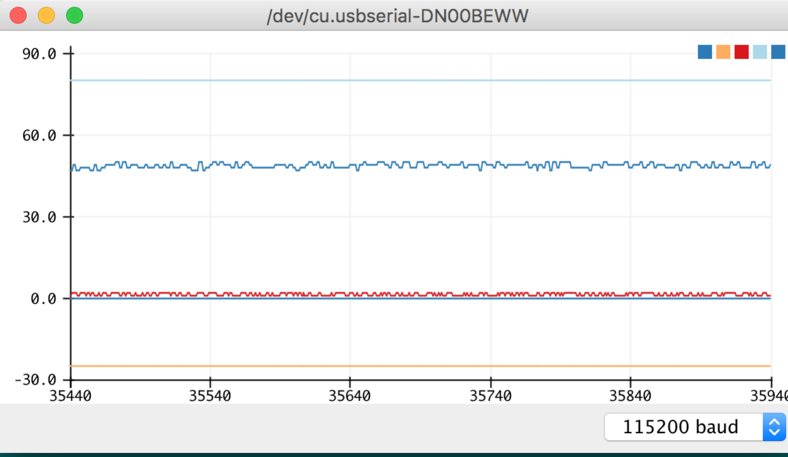OPTION A – Arduino built in Plotter (see above screen-grab) – Select Tools 🡪 Serial Plotter
  2. OPTION B – Telemetry Viewer.
     1. Use the included setup file Footswitch Telemetry Viewer.txt” configuration included in the Arduino project folder “
     2. Select COM port and enjoy

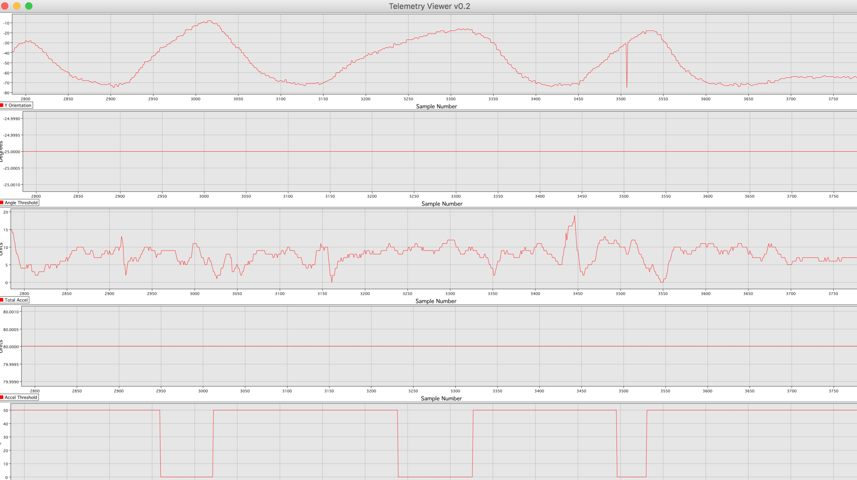

1. PROGRAMMING

For the wired footswitch, just select the device (RFDuino) and the COMport and you are good to go. 🡪 “Upload”

For the other footswitch, I’ve provided an auxiliary programming cable to use with the USB programming dongle.

1. Plug the auxiliary programming cable into the wireless footswitch board.
   1. NOTE: PIN1 is the pin closest to the battery, also noted with a square footprint instead of round.
   2. MAKE SURE YOU GET THIS RIGHT before moving on
2. Disconnect the wired footswitch ribbon cable from the programming dongle.
3. Connect the auxiliary programming cable. NOTE: Pin1 is the brown wire painted with white to match the programming pin1 (also painted white)
4. In the Arduino IDE compile and upload.